

Department of Computer Science and Engineering
Uttara University, Uttara, Dhaka
Assignment on Structured Programming Language
Course Code: CSE0611302
Course Title: Structured Programming Language Lab

Submitted to
Mohsin Hossain
Lecturer
Department of Computer Science and Engineering
Uttara University, Uttara, Dhaka

Submitted by
ABC
Department of Computer Science and Engineering
Uttara University
Semester: Spring-2026
Student Id: 2261091081
Semester: Spring Batch 66 (2026)

Assignment 1: Print integer, float, and char values :
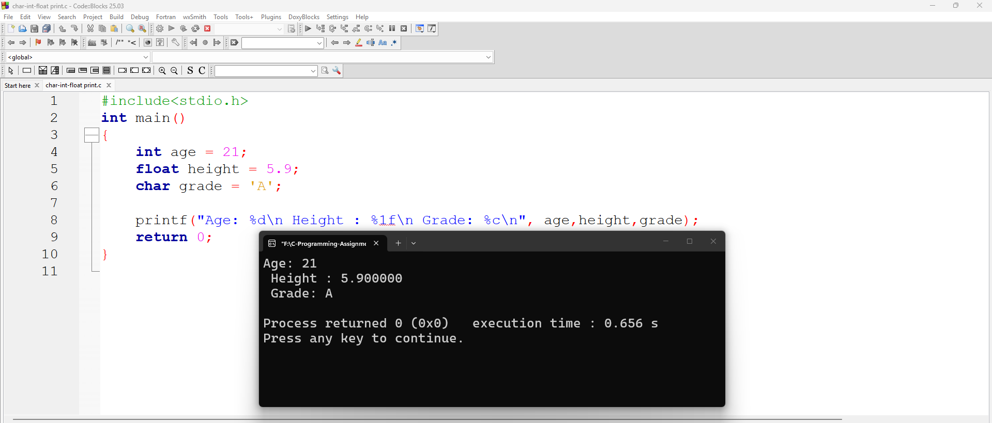

Code:
#include<stdio.h>
int main()
{
int age = 21;
float height = 5.9;
char grade = 'A';
printf("Age: %d\n Height : %1f\n Grade: %c\n", age,height,grade);
return 0;
}
Output:
Age: 21
Height : 5.900000
Grade: A

GitHub Code Link: Click Here.

Assignment 2: Add two integers :
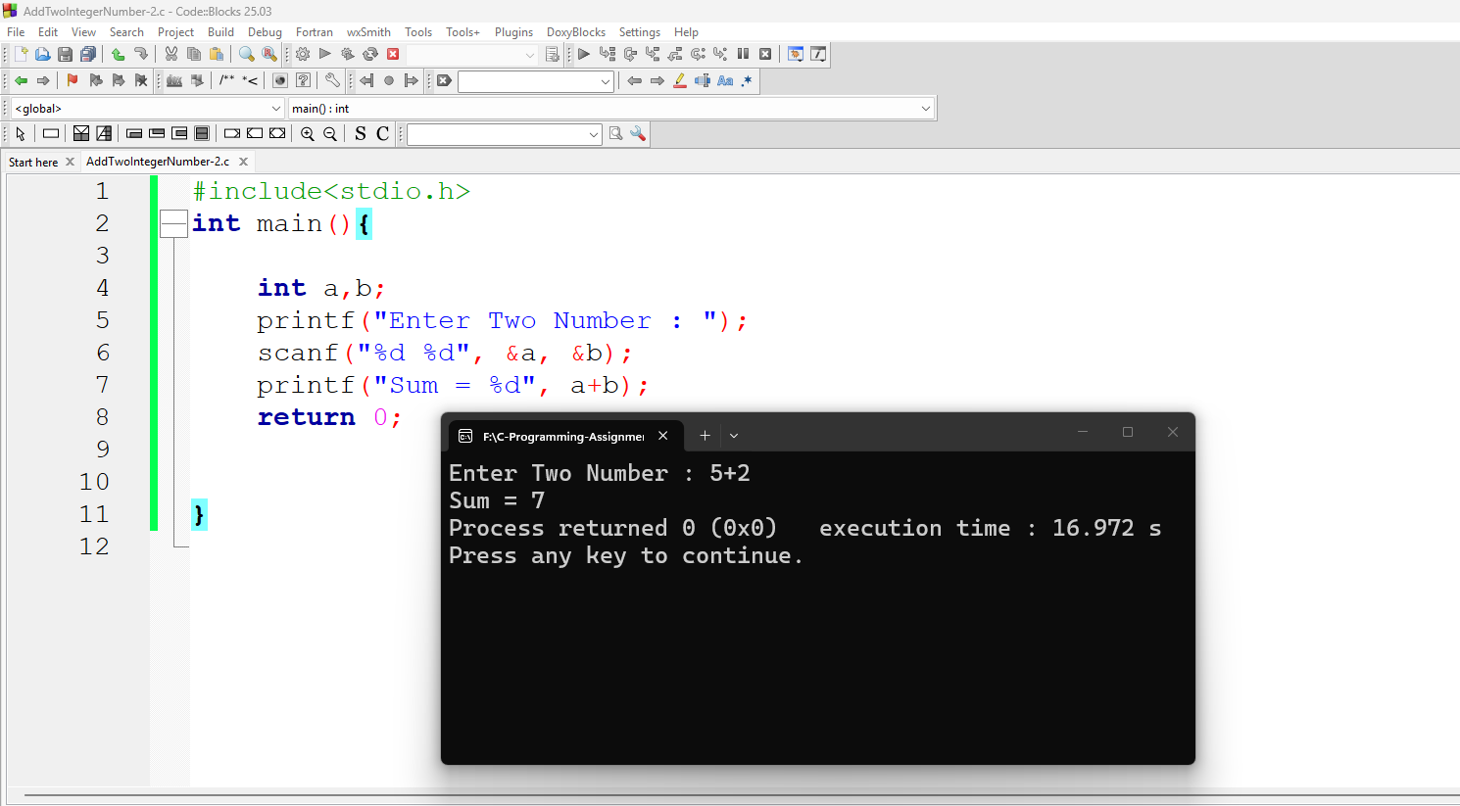
Code:
#include<stdio.h>
int main(){

int a,b;
printf("Enter Two Number : ");
scanf("%d %d", &a, &b);
printf("Sum = %d", a+b);
return 0;
}
Output:
Enter Two Number : 5+2
Sum = 7

GitHub Code Link: Click Here.

Assignment 3: Calculate area of a circle :
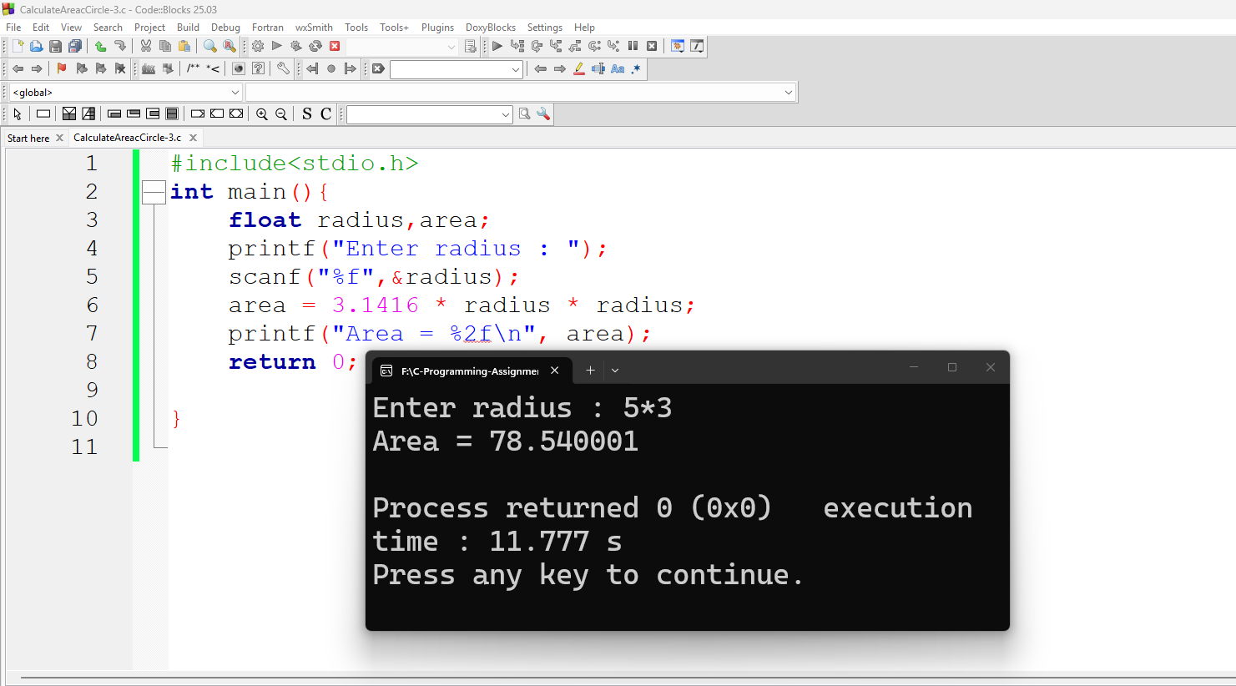
Code :
#include<stdio.h>
int main(){
float radius,area;
printf("Enter radius : ");
scanf("%f",&radius);
area = 3.1416 * radius * radius;
printf("Area = %2f\n", area);
return 0;
}
Output:
Enter radius : 5*3
Area = 78.540001

GitHub Code Link: Click Here.

Assignment 4 : Swap two numbers :
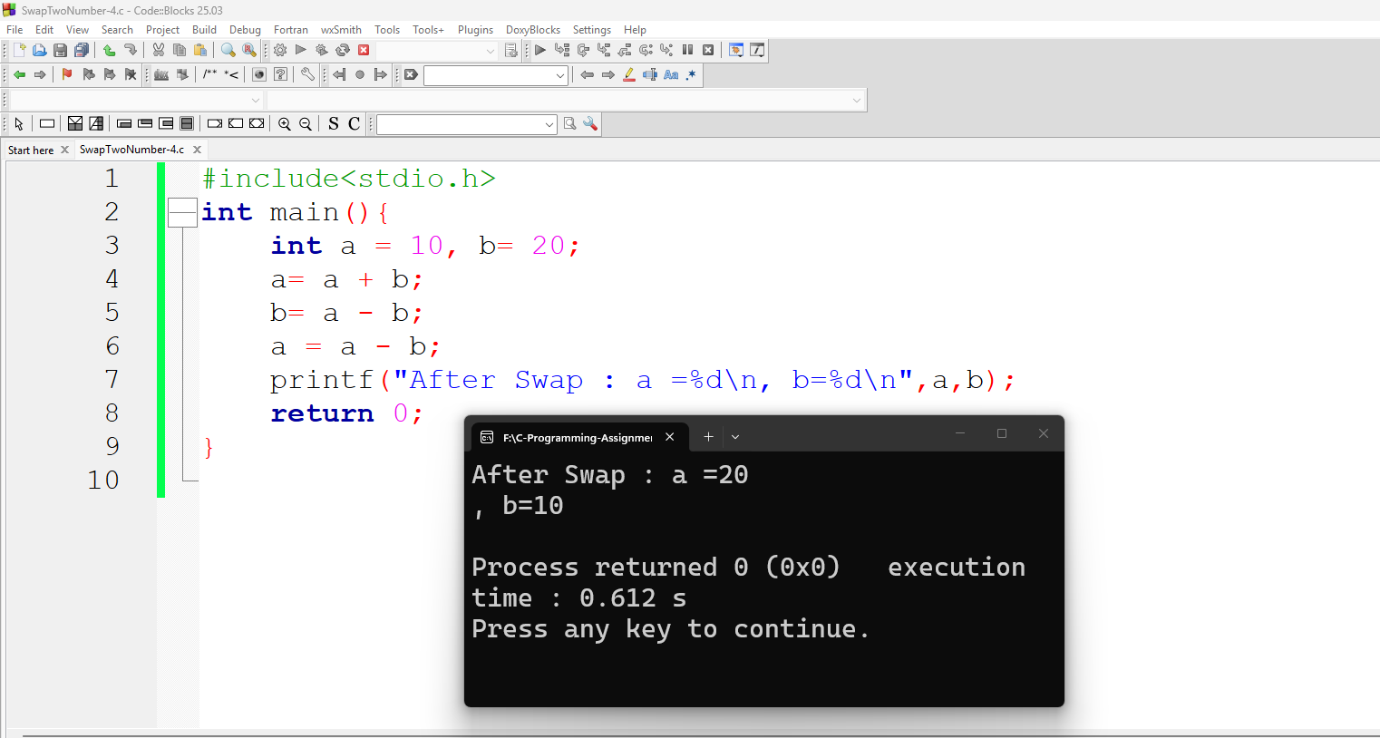

Code :
#include<stdio.h>
int main(){
int a = 10, b= 20;
a= a + b;
b= a - b;
a = a - b;
printf("After Swap : a =%d\n, b=%d\n",a,b);
return 0;
}
Output:
After Swap : a =20
, b=10
GitHub Code Link: Click Here.

Assignment 5 : Find ASCII value :
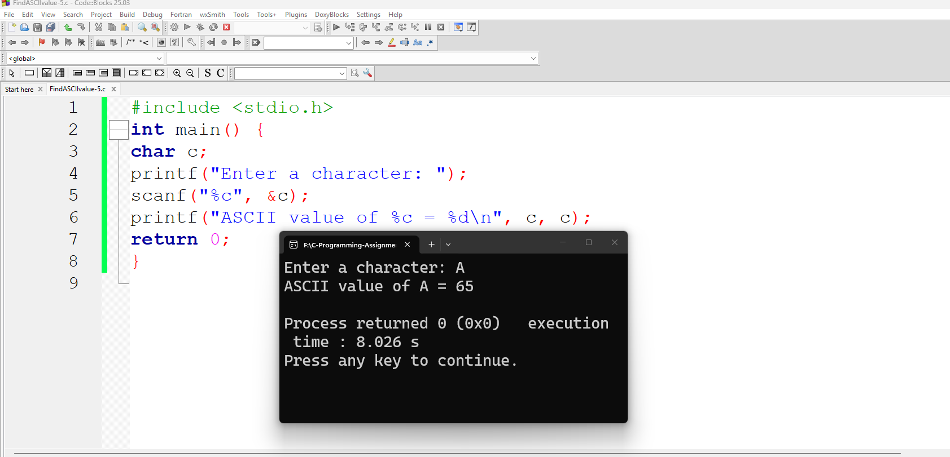
Code:
#include <stdio.h>
int main() {
char c;
printf("Enter a character: ");
scanf("%c", &c);
printf("ASCII value of %c = %d\n", c, c);
return 0;
}
Output:
Enter a character: A
ASCII value of A = 65
, b=10

GitHub Code Link: Click Here.

